**Template for Project submission**

| **TEAM 14** | |
| --- | --- |
| **NAME:** | |
| **ROLL NO:** | |
| **BRANCH:** | |
| **DIV:** | |

The project document should have

1. Problem statement developed from need statement as per template given
2. block diagram / concept diagram explaining mechanical structure and general working of model handwritten diagrams / model using tinkercad / linkage is expected
3. Sensors , actuators and its control achieved using arduino type controller and its code

Simulation of circuit on tinkercad

Timeline: Finalization of theme: Jan 26, 2022

Problem statement and submission of Gantt Chart: Jan 26, 2022

Concept Diagrams / Structure: Feb 03, 2022

Simulation of control: Mar 8, 2022

**Final Submission: Mar 8, 2022**

**Part 1:**

**Timeline and Gantt Chart (Distribution of work and Planning including Part 1)**

| Roll Number | Name of Student | Role played |
| --- | --- | --- |
| 16010221014 | Vidish Ranjan | 3D model,Need statement |
| 16010221020 | Sai Nikhil Uppugunduri | Problem statement, Block Diagram |
| 16010321054 | Siddharth Thole | Gantt Chart,Problem Statement |
| 16010221024 | Adithe Shivaram | Need Statement,Gantt Chart |
| 16010521034 | Aaron Rodrigues | 3D Model,Block Diagram |

**GANTT CHART:**

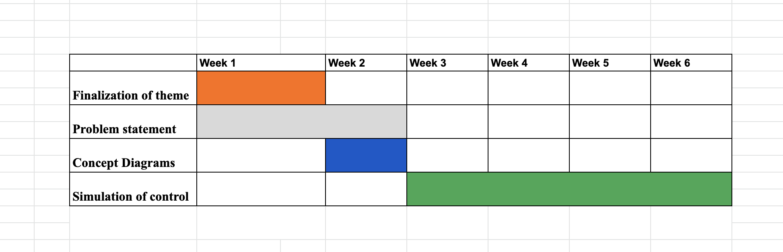

**Need Statement:**

**Table 1: List of The sample Questionnaire to design the problem**

| **Questions such as** | **This question helps the designer to** |
| --- | --- |
| 1. Is the product energy efficient? | **Identify client’s objective** |
| 1. Is the product easy to operate? |
| 1. How easy is the product to be repaired in case of malfunctions? |
| 1. Is the installation process simple ? |
| 1. Is the app integration user friendly? |
|  |
| 1. The product being expensive. | **Identify constraints** |
| 1. Installation process is tedious. |
| 1. difficulty in differentiating between similar weights. |
|  |
| 1. It can be operated via voice assistance. | **Establish functions** |
| 1. Can be integrated in the security system for homes. |
| 1. Can be also used as an accessibility feature of the differently abled. |
|  |

**Table 2 The information obtained through basic research and Survey**

| **Observation and from Lit.Survey** | **Requirements** |
| --- | --- |
| 1. The product is very expensive | The developer needs to look into ways of cost cutting |
| 1. Difficulty in installation of the product. | The developer can work on an easier and faster method of installation |
| 1. Any fault in the product cannot be identified by the user and hence has to be rectified by the technician only | The product must be installed with a smart diagnosis feature which will automatically indicate the user in case of technical faults |
| 1. Distinguishing between two similar weights might be an issue | A prompt system can be setup which will notify the user in case of such an issue |
| 1. There's no alternative installation method which can be done without interfering with the floorings. | Developer can work on a chip system which will also help in tracking and doing the same functionalities |

**1.1 Establish client’s objectives**

The target audience aims to purchase a smart home device which must be energy efficient,easy to operate,budget friendly and ease of access.For this, they’re looking for a product which comes with an user-friendly app and voice assistance.

**1.2 Identify constraints**

One of the biggest constraints faced by the customers is the pricing of the product and about the complications regarding the installation process of said product.It may also face difficulty in differentiating between two similar weights which might cause inconvenience

**1.3 Establish functions**

It provides the user with the feature of using voice assistance which is highly convenient.it can be used as an accessibility product which will help the blind in navigating through the facility. It can also be used as a security surveillance device when needed.

**Revised Problem Statement**:

Design a smart home device which controls various appliances when an individual walks on their floor. It needs to be energy efficient, simple to operate, budget friendly and easily accessible. It also needs to come with a user-friendly app and a voice assistance feature.

* **Part 2:**

**Design Specifications**

Students can submit either of following in order to explain the design and working of idea

* Block diagram
* 3 D model of design
* mechanism models
* hand drawings/ sketches of ideas
* List of components needed for implementation

**Block Diagram:**

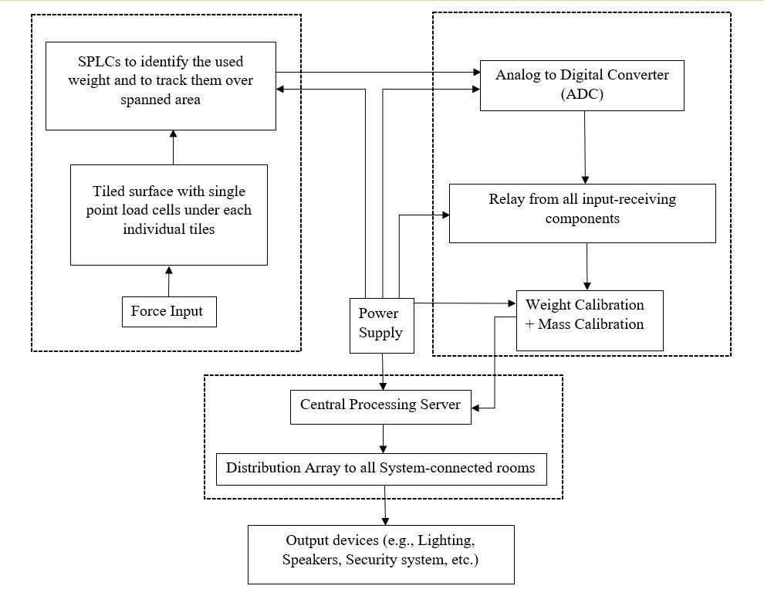

**3D MODEL:**

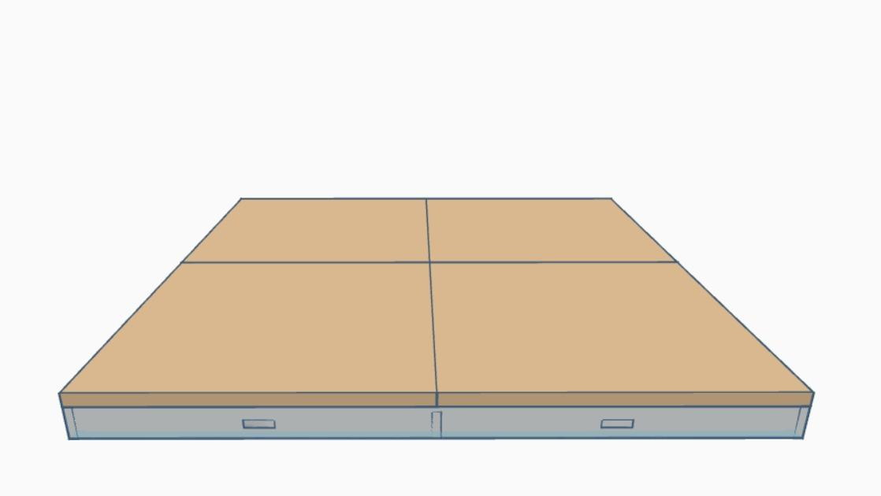

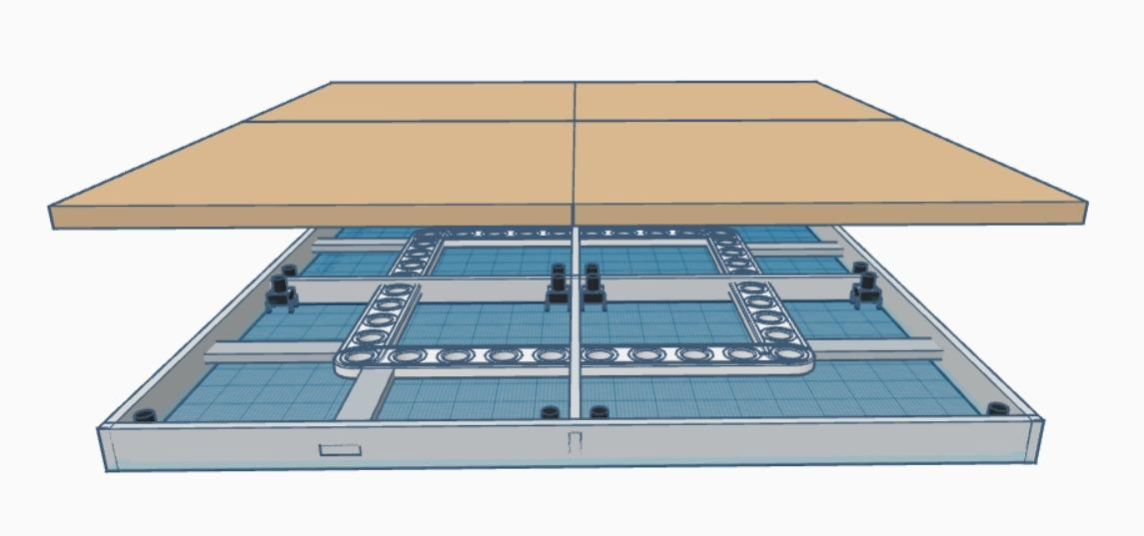

**INTERNAL DESIGN:**

